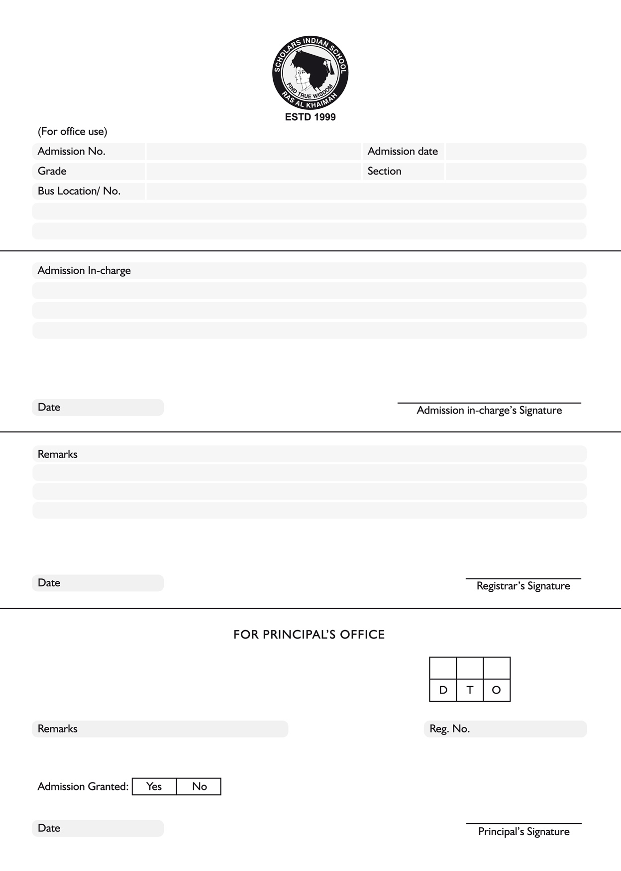

xfgsgsgs

xfgsgsgs

xfgsgsgs

xfgsgsgs

xfgsgsgs

xfgsgsgs

xfgsgsgs

xfgsgsgs

xfgsgsgs

xfgsgsgs

xfgsgsgs

xfgsgsgs

xfgsgsgs

xfgsgsgs

xfgsgsgs

xfgsgsgs

xfgsgsgs

xfgsgsgs

xfgsgsgs

xfgsgsgs